Software Requirements Specification
for
Weather Forecast
Prepared by Dhruv Gajjar
Guided by Rupal Lakhani

Table of Contents
Table of Contents ii
Revision History
1. Introduction 1
1.1 Purpose 1
1.2 Document Conventions 1
1.3 Intended Audience and Reading Suggestions 1
1.4 Product Scope 1
1.5 References 1
2. Overall Description 2
2.1 Product Perspective 2
2.2 Product Functions 2
2.3 User Classes and Characteristics 2
2.4 Operating Environment 2
2.5 Design and Implementation Constraints 2
2.6 User Documentation 3
2.7 Assumptions and Dependencies 3
3. External Interface Requirements 3
3.1 User Interfaces 3
3.2 Hardware Interfaces 3
3.3 Software Interfaces 3
3.4 Communications Interfaces 3
4. System Features 4
4.1 System Feature 1
4.2 System Feature 2 (and so on)
5. Other Nonfunctional Requirements 5
5.1 Performance Requirements 5
5.2 Safety Requirements 5
5.3 Security Requirements 6
5.4 Software Quality Attributes 6
5.5 Business Rules 6
6. Other Requirements 6
Appendix A: Glossary 6
Appendix B: Analysis Models 7

Introduction

Purpose
The purpose of this program is to create an interactive and engaging quiz on car-related topics. It aims to test and enhance the participants' knowledge about automobiles, covering a wide range of aspects from car manufacturers and models to technical details and automotive history. This program provides an enjoyable and educational experience for car enthusiasts and learners alike while promoting an understanding of the world of automobiles..

Document Conventions
The format of this Software Requirement Specifications for Random quize System is simple. Bold face and indentation is used on general topics and on specific points of interest. The rest of the document will be written using the standard font, Times New Roman.

Intended Audience and Reading Suggestions
The intended readers of this document are the developers of the station, testers, station owners, managers and coordinators. In case of any suggested changes on the requirements listed on this document should be included in the last version of it so it can be a reference to developing and validating teams.

Product Scope
The product scope encompasses a web-based quiz application, offering 10 multiple-choice questions on related topics. Users can test their knowledge and enjoy an engaging quiz experience.

References
IEEE 830-1998 standard for writing SRS document. IEEE Std 1233, 1998 Edition, IEEE guide for developing system requirement specification.

Overall Description

Product Perspective
The product perspective involves developing a versatile web-based quiz application. It should be accessible from various devices and browsers, enabling users to enjoy interactive quizzes on a wide range of topics, from general knowledge to specific subjects like cars, technology, history, and more. The application is designed for easy navigation, question progression, and result display. Users, educators, and enthusiasts can benefit from the application's flexibility and expandability, with the potential for adding more questions and features in the future, making it suitable for a broad audience and a variety of educational purposes.

Product Functions
- Quiz Creation and Management
- Multiple-Choice Question Format
- Scoring and Result Display
- Topic Selection and Customization
- Educational and Entertainment Value

User Classes and Characteristics
User classes include Participants (quiz takers), Educators (quiz creators), Enthusiasts (passionate users), Administrators (site managers), Developers (technical team), Content Contributors, and Social Connectors, each with specific roles and interactions

.Operating Environment
The operating environment is web-based, accessible from various browsers and devices. It requires internet connectivity for user access, making it platform-independent and user-friendly..

Design and Implementation Constraints
Design and implementation constraints include adhering to web standards, ensuring cross-browser compatibility, and optimizing for mobile devices. The application should be secure, scalable, and user-friendly, accommodating potential traffic spikes. Data privacy and accessibility compliance, as well as efficient database management, are essential considerations.

User Documentation
User documentation includes a comprehensive guide covering registration, quiz taking, and managing profiles. It offers clear instructions on using various features, understanding scoring, and accessing educational resources. Additionally, FAQ sections and video tutorials enhance the user's experience and understanding of the application.

Assumptions and Dependencies
Assumptions and dependencies for the quiz application involve a reliable internet connection for users. Additionally, it assumes the availability of third-party services for features like social sharing. Dependencies also include the hosting environment and server capabilities for smooth operation..

External Interface Requirements

User Interfaces
Homepage: Features topic selection and quiz start.
Quiz Interface: Displays questions, options, and a timer.
Result Screen: Shows scores and correct answers.

Hardware Interfaces
Quize system doesn’t need any hardware requirement. It only need device that has location and web browsing services.

Software Interfaces
The quiz application utilizes software interfaces for seamless integration of HTML, CSS, and JavaScript. HTML structures content, CSS enhances styling, and JavaScript adds interactivity. These technologies interact to create an interactive and visually appealing user interface, ensuring smooth user experiences.

Communications Interfaces
Communications interfaces involve data exchange between the quiz application and external services. These interfaces include API endpoints for social media sharing, content delivery networks for multimedia resources, and secure data transmission protocols to protect user information. Effective communication interfaces enable efficient integration and a smooth user experience.

System Features
Following are the functionalities of the weather forecast that are must for the system to work properly, to fulfil its purpose, and provide a desirable output.

User location and welcome
When website is launched, it will ask user to give location access. After giving permission, it will show all details of weather forecast.
4.1.1 Description and Priority
For the user to get area weather, it is must that he let site to detect his location, so it can give output of the desired area. This feature has the top priority without this it won’t run.
4.1.2 Stimulus/Response Sequences
Step1: User will launch the site.
Step2: website will ask for permission to access location.
Step3: User shall permit the site to access the location.
Step4: website saves the input.

4.1.3 Functional Requirements

REQ-1: Website shall ask to access the location.

Current Weather
This Website shows the current weather. It shows us weather in words with degrees outside. Also there is pictorial view at the right side of the screen. So that we can easily know what type of weather it is. There is small icon of an arrow on the right side that shows us details of current weather. Following are the details:
- Humidity
- UV index
- Wind speed
- Cloud cover
- Winds from
- Wind gust
- Dew point
- Pressure
- Visibility

4.2.1 Description and Priority
For the user to get instant weather update they will simply open this site. So that they can view current weather of the day. This feature’s priority is high because this is like main screen.
4.2.2 Stimulus/Response Sequences
Step1: User will launch the site
Step2: User shall allow location permission
4.2.3 Functional Requirements
REQ-1: User launch the site
REQ-2: User shall allow location permission for further information

Looking Ahead
User can see overview of the week in one bar. If all the week has been sunny but there are unexpected showers. It will show us the predicted day. It is on main screen. User just has to swipe down. It is for user to plan ahead of time. So he can delay plans or make adjustments in schedule accordingly. It even shows us the day on which to expect the unexpected change.
4.3.1 Description and Priority
It is for the user to see over view of the week. User shall know what weather to expect in the week.
4.3.2 Stimulus/Response Sequences
Step 1: user will scroll down
Step 2: user can read any unexpected weather update
4.3.3 Functional Requirements
REQ-1: user shall scroll down

Other Nonfunctional Requirements

Performance Requirements
The performance should be able to support at least 10 simultaneous users. Data should be secured and backed up every day. Response time of the software is less than 5 seconds. Software should be opera table 24 hours and accessible in real time. Actions are performed very quickly. This software application will not stuck and halt on any type of action.

Safety Requirements
Weather forecast will not damage or affect the other applications installed in the system and also not the performance of the system. The safety concerned with this software application that app should not been abled when your device is used by any other person and if you are crossing a road or may be ride a bicycle/bike/car and engage in other activity.

Security Requirements
It is used by only one user at a time. It will only need location of the user to get weather information of user’s area. It will not share location to any other.

Software Quality Attributes
The graphical user interface (GUI) design by usability. This site is user friendly and organized in this style that user can easy to navigate. To ensure reliability and correctness there will be zero forbearance for errors in the algorithms. For flexibility and adaptability if the user disconnect with the internet or having weak connectivity the user still able to use the site till the connection established.

Business Rules
<List any operating principles about the product, such as which individuals or roles can perform which functions under specific circumstances. These are not functional requirements in themselves, but they may imply certain functional requirements to enforce the rules.>
User have to accept our terms and conditions. We insure that user’s data will be protected and it will be not miss used at any cost. This site is free for all users.

Other Requirements
- External Requirements: Requirements which arise from factors which are external to the system and its development process e.g. interoperability requirements, legislatives requirements, etc.
- Product Requirements: Requirements which specify that the delivered product must be have in a particular way e.g. execution, speed, reliability, etc.
- Organizational Requirements: Requirements which are a consequence of organization policies and procedures e.g. process standers used, implementation requirements, etc.

Appendix A: Glossary
- API (Application Programming Interface) – a set of routines, protocols and tools for building software and applications.
- ASP Pages (Active Server Pages) – Microsoft’s first server-side script engine for dynamically generated web pages.
- HTML (HyperText Markup Language) – the standard markup language used to create web pages.
- CSS (Cascading Style Sheets) – a style sheet language used for describing the presentation of a document written in a markup language.
- Javascript – a high -level, dynamic, un-typed, and interpreted programming language.
Appendix B: Analysis Models
- ER Diagram: An ER diagram shows the relationship among entity sets. An entity set is a group of similar entities and these entities can have attributes. In terms of DBMS, an entity is a table or attribute of a table in database, so by showing relationship among tables and their attributes, ER diagram shows the complete logical structure of a database. Lets have a look at a simple ER diagram to understand this concept.
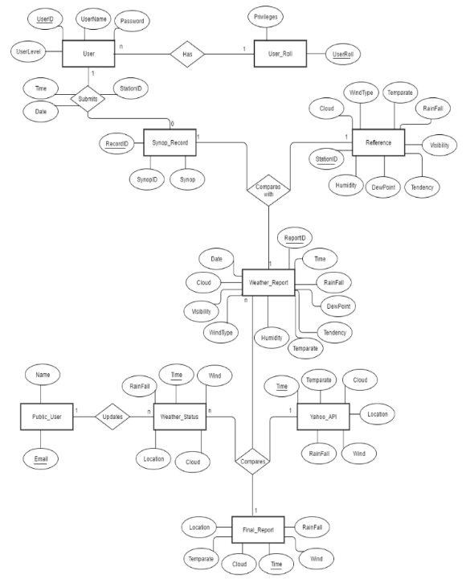
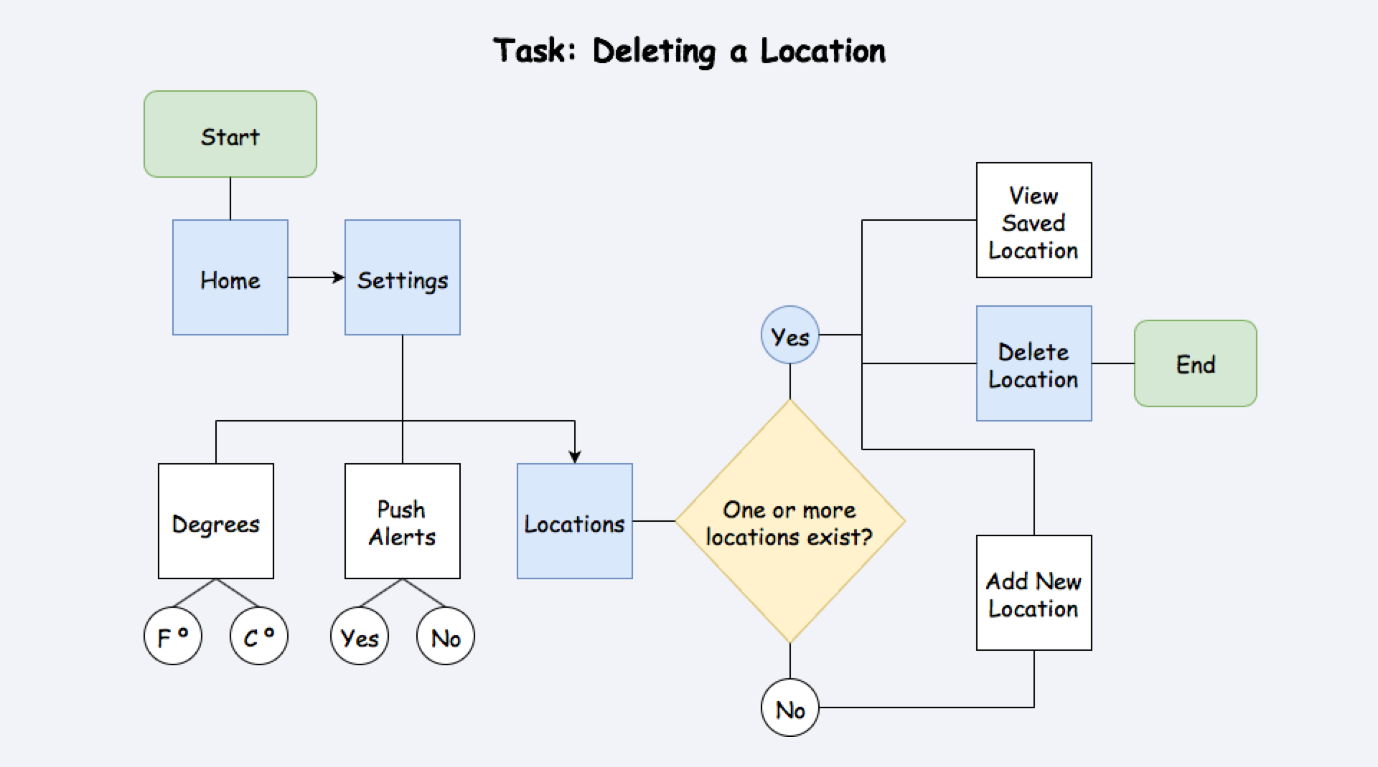
- Data Flow Diagram: A data flow diagram (DFD) is a graphical representation of the "flow" of data through an information system, modeling its process aspects.

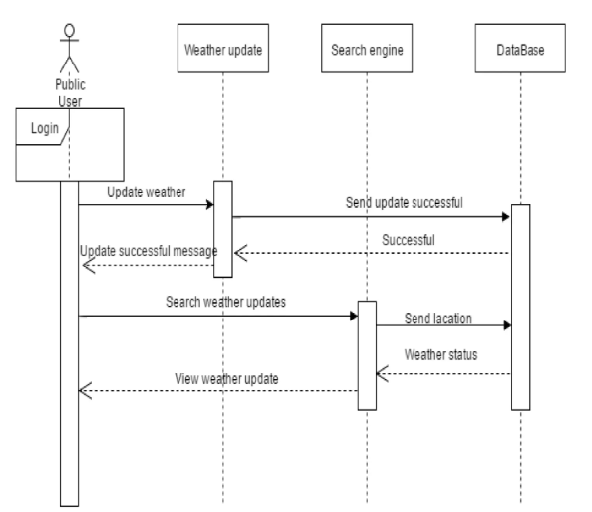
- Sequence Diagram: A Sequence diagram is an interaction diagram that shows how objects operate with one another and in what order. It is a construct of a message sequence chart. A sequence diagram shows object interactions arranged in time sequence.

